




Digital Design Verification FYP/Internship Program
LAB # 01
GCC Compiler, GNU Debugger and Data Types,

Name: Abdul Hadi Afzal
Date: 25-02-2025

Table of Contents
Task 1: 3
PART 1 (Default): 3
PART 1 (Errors Fixed): 3
PART 2 : 3
PART 3: 4
PART 4: (Introducing an error): 4
PART 4 (Fixing the error): 5
Task 2: 7
Task 3: 8
Task 4: 9
Task 5: 9
Task 6: 10
Task 7: 10
Conclusion:……………………………………………………………………………………..12

Task 1:

PART 1 (Default):

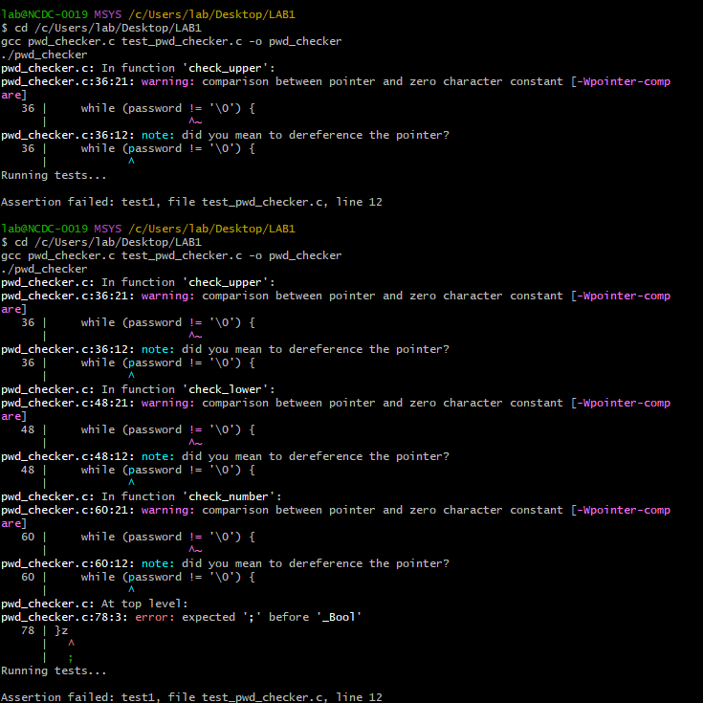

PART 1 (Errors Fixed):

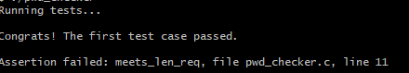

PART 2 :

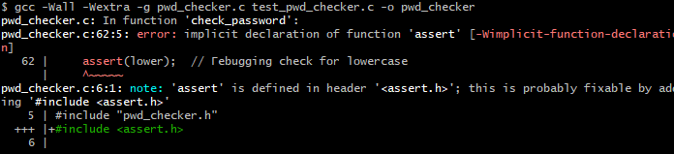

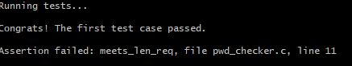

PART 3:

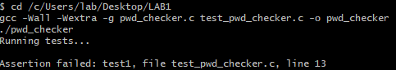

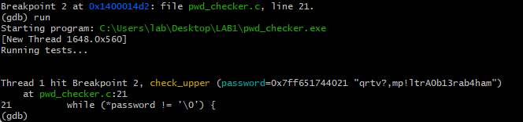

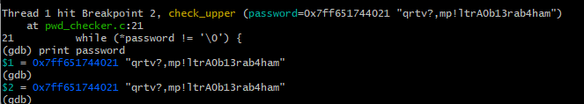

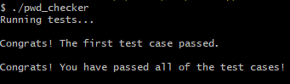

PART 4: (Introducing an error):

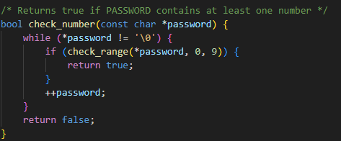

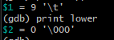

PART 4 (Fixing the error):

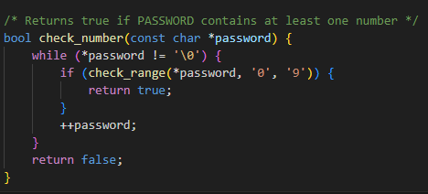

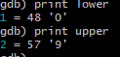

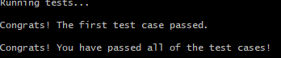

Final Code:
Pwd_checker.c:
/********************************************
* Author: AbdulHadi Afzal *
* Task: Password Strength Checker *
********************************************/

#include <stdio.h>
#include <stdbool.h>
#include <string.h>
#include "pwd_checker.h"

bool check_length(const char *password) {
int length = strlen(password);
return (length >= 10);
}

bool check_range(char letter, char lower, char upper) {
return (letter >= lower && letter <= upper);
}

bool check_upper(const char *password) {
while (*password != '\0') {
if (check_range(*password, 'A', 'Z')) {
return true;
}
password++;
}
return false;
}

bool check_lower(const char *password) {
while (*password != '\0') {
if (check_range(*password, 'a', 'z')) {
return true;
}
++password;
}
return false;
}

bool check_number(const char *password) {
while (*password != '\0') {
if (check_range(*password, '0', '9')) {
return true;
}
++password;
}
return false;
}

bool check_name(const char *first_name, const char *last_name, const char *password) {
return !(strstr(password, first_name) || strstr(password, last_name));
}

/* Ensures password meets all security conditions */
bool check_password(const char *first_name, const char *last_name, const char *password) {
return check_length(password) && check_upper(password) && check_lower(password) && check_number(password) && check_name(first_name, last_name, password);}

test_pwd_checker.c:
/********************************************
* Author: AbdulHadi Afzal *
* Task: Password Checker Test Cases *
********************************************/

#include <assert.h>
#include <stdio.h>
#include "pwd_checker.h"

int main() {
printf("Running tests...\n\n");

// Test Case 1: This password should pass all checks
const char *test1_first = "Abraham";
const char *test1_last = "Garcia";
const char *test1_pwd = "qrtv?,mp!ltrA0b13rab4ham";
bool test1 = check_password(test1_first, test1_last, test1_pwd);
assert(test1);
printf("First test case passed.\n\n");

// Test Case 2: Too short (Fails check_length)
const char *test2_first = "John";
const char *test2_last = "Doe";
const char *test2_pwd = "Short1";
bool test2 = check_password(test2_first, test2_last, test2_pwd);
assert(!test2);

// Test Case 3: No uppercase letter (Fails check_upper)
const char *test3_pwd = "alllowercase1";
bool test3 = check_password(test2_first, test2_last, test3_pwd);
assert(!test3);

// Test Case 4: No number (Fails check_number)
const char *test4_pwd = "NoNumbersHere";
bool test4 = check_password(test2_first, test2_last, test4_pwd);
assert(!test4);

// Test Case 5: Contains first name (Fails check_name)
const char *test5_pwd = "JohnRocks123";
bool test5 = check_password(test2_first, test2_last, test5_pwd);
assert(!test5);

printf("All test cases passed successfully.\n");
return 0;
}

Task 2:

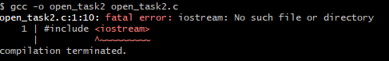
/********************************************
* Author: AbdulHadi Afzal *
* Task: Character Operations & Data Sizes *
********************************************/

#include <stdio.h>

int main() {
char chChar;

printf("Enter a character: ");
scanf(" %c", &chChar);

printf("You entered: %c\n", chChar);
printf("ASCII Value: %d\n", chChar);

chChar = chChar + 7;
printf("After adding 7: %c\n", chChar);

chChar = 'd';
printf("Final character: %c\n", chChar);

printf("\n----- Data Type Sizes -----\n");
printf("Size of char: %lu byte\n", sizeof(char));
printf("Size of int: %lu bytes\n", sizeof(int));
printf("Size of float: %lu bytes\n", sizeof(float));
printf("Size of double: %lu bytes\n", sizeof(double));

return 0;
}

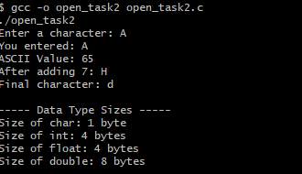

Task 3:
/****************************************************
* Author: AbdulHadi Afzal
* Task: ASCII Name & CMS ID Display
****************************************************/

#include <stdio.h>

int main() {
char lastCharName = 'i'; // Last letter of "Hadi"
char lastCharCMS = '0'; // Last digit of CMS ID "413970"

// Display Name using ASCII values
printf("Name: %c%c%c%c\n", 72, 97, 100, lastCharName);

// Display CMS ID
printf("CMS ID: %d%d%d%d%d%c\n", 4, 1, 3, 9, 7, lastCharCMS);

return 0;
}

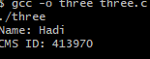

Task 4:

/****************************************************
* Author: AbdulHadi Afzal
* Task: Integer Arithmetic Operations
****************************************************/

#include <stdio.h>

int main() {
// Performing integer arithmetic calculations
printf("35 / 5 = %d\n", 35 / 5);
printf("36 / 7 = %d\n", 36 / 7);
printf("18 - 32 / 6 * 3 = %d\n", 18 - 32 / 6 * 3);
printf("220 / 5 = %d\n", 220 / 5);
printf("27 - 7%%3 + 8/3 = %d\n", 27 - 7 % 3 + 8 / 3);

return 0;
}

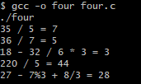

Task 5:
/****************************************************
* Author: AbdulHadi Afzal
* Task: Semester GPA Calculation
****************************************************/

#include <stdio.h>

int main() {
int n, i;
float totalPoints = 0, totalCredits = 0, gpa, grade, credit;

printf("Enter number of courses: ");
scanf("%d", &n);

for (i = 1; i <= n; i++) {
printf("Enter credit hours for course %d: ", i);
scanf("%f", &credit);

printf("Enter grade points (e.g., 4.0, 3.5) for course %d: ", i);
scanf("%f", &grade);

totalPoints += credit * grade;
totalCredits += credit;
}

// Calculate GPA
gpa = totalPoints / totalCredits;
printf("\nYour Semester GPA is: %.2f\n", gpa);

return 0;
}

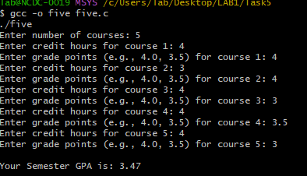

Task 6:
/****************************************************
* Author: AbdulHadi Afzal
* Task: Kirchhoff’s Current Law Calculation
****************************************************/

#include <stdio.h>

int main() {
float V1, R1, R2, R3, i1, i2, i3;

printf("Enter Voltage (V1): ");
scanf("%f", &V1);

printf("Enter Resistance R1: ");
scanf("%f", &R1);

printf("Enter Resistance R2: ");
scanf("%f", &R2);

printf("Enter Resistance R3: ");
scanf("%f", &R3);

// Calculate currents using Ohm's Law and Kirchhoff’s Current Law
i1 = V1 / R1;
i2 = V1 / R2;
i3 = i1 - i2;

printf("\nCalculated Currents:\n");
printf("i1 = %.2f A\n", i1);
printf("i2 = %.2f A\n", i2);
printf("i3 = %.2f A\n", i3);

return 0;
}

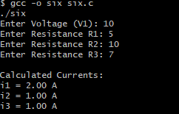

Task 7:
/****************************************************
* Author: AbdulHadi Afzal
* Task: Quadratic Equation Extrema Finder
****************************************************/

#include <stdio.h>

// Function to calculate extrema
void find_extrema(double a, double b, double c) {
if (a == 0) {
printf("Not a quadratic equation.\n");
return;
}

double x = -b / (2 * a);
double y = a * x * x + b * x + c;

printf("Extrema at x = %.2f, y = %.2f\n", x, y);

if (a > 0)
printf("This is a Minimum point.\n");
else
printf("This is a Maximum point.\n");
}

int main() {
double a, b, c;

printf("Enter coefficients a, b, and c: ");
scanf("%lf %lf %lf", &a, &b, &c);

find_extrema(a, b, c);

return 0;
}

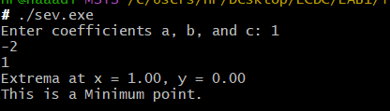

Flow Chart:

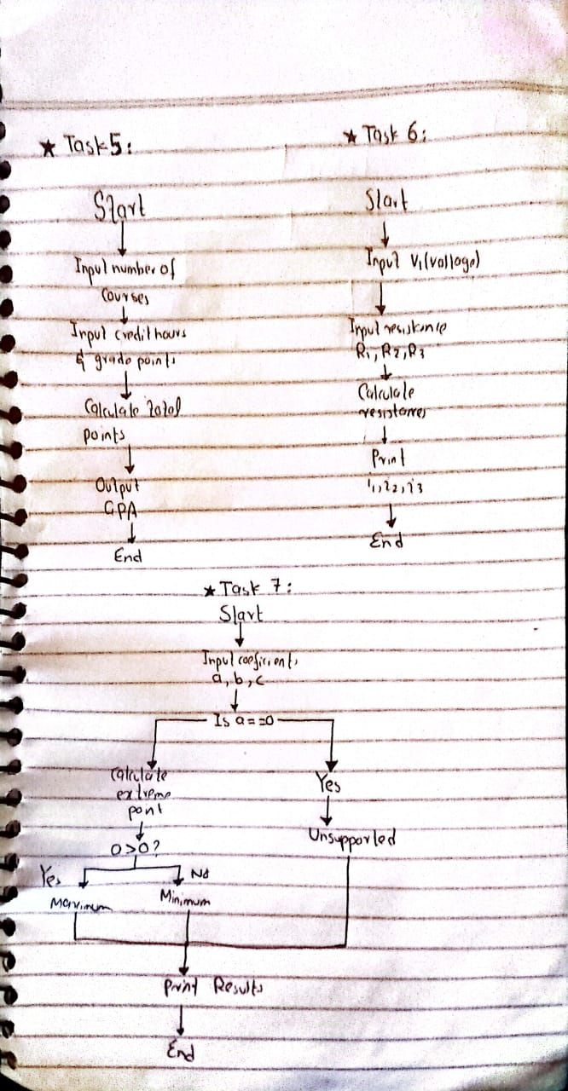

Conclusion
This lab introduced essential concepts of compiling, debugging, and working with data types in C. The exercises helped reinforce theoretical concepts with practical applications.

